

KIDS Game Rules
Season 2026

WRO themed game for students 6 to 10 years old
for use at a national level



Ancient Artefacts

Table of content
1. Introduction 3
2. Game Field 3
3. Game Objects and Positioning 4
4. Robot Missions 5
1. Bring the column to the pantheon 5
2. Let the water in Shushtar flow 5
3. Win the ball game in Chichen-Itza 5
4. Bring the houseboat in Angkor Wat to its correct position 5
5. Bring the treasures from all corners to the Museum 6
6. Park the robot 6
7. Get bonus points and avoid penalties 6
5. Specific Game Rules & General Rules 7
6. Scoring 9

Information on how to use these game rules in countries:
This game is made for use in countries. There is no international competition for this game. National Organizers are free to adapt these game rules, so they fit the situation in their country.

Please check chapter 5 for specific rules about allowed materials and the flow of the game and competition for this starter game!

Introduction
Long ago, many different groups of people built amazing cities and created their own ways of living. Some of these groups disappeared, but others kept their traditions alive and passed them on to their children. Today, we can still see old buildings and special objects that remind us of how people lived in the past. Museums help protect these treasures so everyone can learn from them. They show us how creative people were, what they believed in, and what was important to them.

Now it’s your turn to help keep this history alive. You can collect old objects and bring them safely to the museum. You can also keep traditions going by trying things people still do today, like playing an ancient ball game or helping families move their houseboats.

Game Field
The following graphic shows the game field with the different areas.

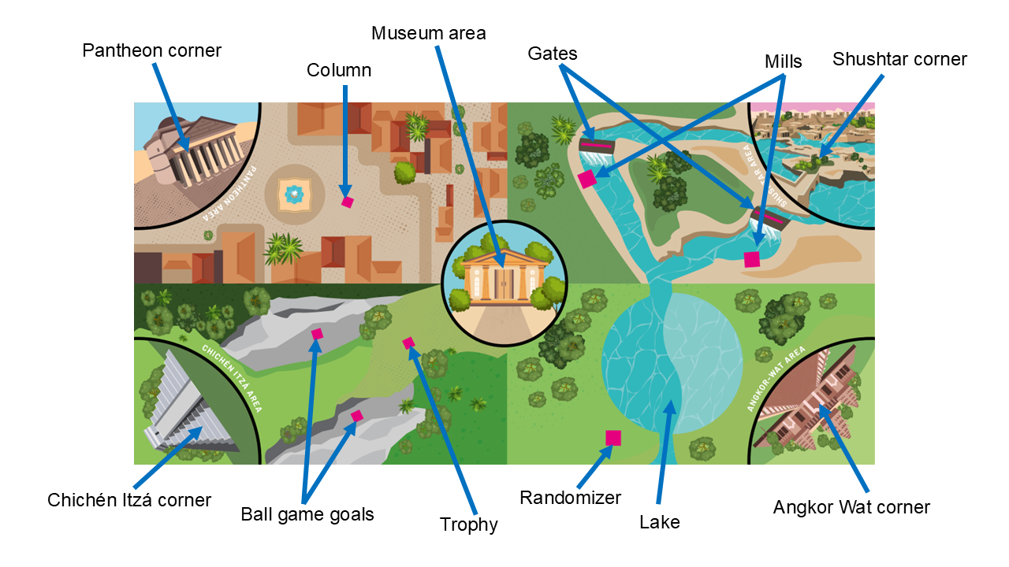
If the table is larger than the game mat, place the corner of the SAFE CHICHEN-ITZA AREA in the corner of the game field and align both sides of that area with the borders.

For more information about the table and game mat specifications, please take a look at WRO RoboMission Category General Rules.

Game Objects and Positioning

- 1 column is placed in the square in front of the Pantheon.
- 2 goals are placed in front of Chichén Itzá.
- 1 trophy is placed in the area of Chichén Itzá.
- 2 gates are placed on the waterways of Shushtar.
- 2 mills are placed at the two waterways in Shushtar.
- 1 randomizer is placed near the lake of Angkor Wat
- 1 boat is placed in the SAFE ANGKOR WAT AREA
- 4 artifacts are placed in the corners. One artifact in each corner.

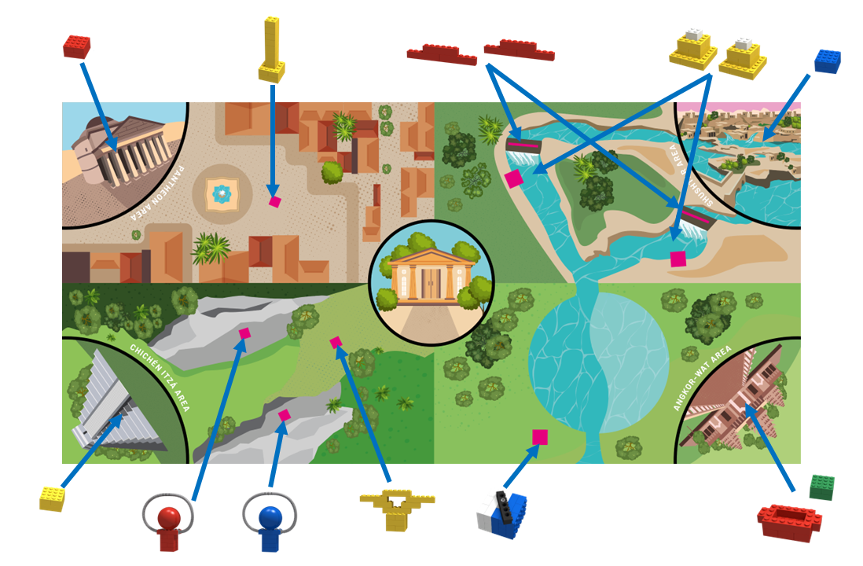

Robot Missions

For greater clarity, the missions will be explained in multiple sections. The team can decide which parts of the missions they will do and in which order. Final scoring will be based on the situation on the field at the end of the run. So, if an object was correctly placed but is accidentally moved out of the area and therefore not in the area by the end of the game, no points are given for this task

Bring the column to the pantheon
While building a new house in the city, an ancient column was found. At the current location, there is not enough space to exhibit it. Therefore, it is necessary to bring it to the pantheon to showcase it there.

The column in the city must be moved to the SAFE PANTHEON AREA. Points are only given if the column is completely in the SAFE PANTHEON AREA and is not damaged. The line belongs to the SAFE PANTHEON AREA.

Let the water in Shushtar flow
In Shushtar there are many streams that are being used to power mills. To make sure that the water only flows where it is needed, there are a lot of gates to control the water. We want to use the two mills, so open the gates in front of the mills!

The gates (2) must be moved outside the streams, so the water can flow freely. Points are given, when the gate doesn’t touch the blue streams anymore.

The mills (2) should not be moved or damaged.

Win the ball game in Chichen-Itza
The ancient city of Chichen-Itza was famous for its ball game, a ritual sport that played an important role in Maya culture. To recreate this challenge, your robot must activate the game and claim the award by following the correct sequence.

The balls (2) must be pushed off the goals without moving or damaging the goals.
Points are given when a ball touches the game mat, no matter where on the game field.

When both balls touch the game mat, the game is won and the trophy has to be moved into the SAFE CHICHEN-ITZA AREA.
Points are only given, when trophy is standing upright, without damage and touching the game mat inside the SAFE CHICHEN-ITZA AREA.

Bring the houseboat in Angkor Wat to its correct position
Around the temple in Angkor Wat there is a lot of water. Due to the changes in seasons, the water levels in the rivers and lakes change. Therefore, some of the people there live in house boats, which create floating villages. But because of the change in water level, they have to move their floating houses, either to deeper or more shallow water.
Help the village and bring a new houseboat to the correct part of the lake!

There is a randomizer between the lake and the border of the game field. The black indicator of the randomizer will be spun once by a judge before each round. Based on this, all randomizers on all tables will be set to this position.

The houseboat (1) must be moved from the SAFE ANGKOR WAT AREA to either the bright blue or dark blue part of the lake, indicated by the randomizer. When the black indicator of the randomizer points to the white area of the randomizer, the houseboat hast to be moved to the bright blue area of the lake. When the indicator of the randomizer points to the blue area, the houseboat has to be brought to the dark blue area of the lake. Points are given, when the houseboat is touching the game mat and completely or partly inside the correct area of the lake.

Bring the treasures from all corners to the Museum
There are a lot of interesting treasures from all over the world that should be exhibited in a museum for everyone to see.

In each SAFE AREA (4) there is a treasure that has to be brought to the MUSEUM AREA in the middle of the game field by the robot. Moving the treasures by hand or moving the robot by hand while a treasure is on the robot is not allowed.
Points are awarded, when the treasure is completely inside the MUSEUM AREA in the middle of the game field. The line belongs to the area.
When all four treasures are in the MUSEUM AREA a bonus is given.

Park the robot
Try to park your robot in the central round MUSEUM AREA. Points are given if the robot stops there, and its projection is completely (top-view) within the Parking Area – the line belongs to the area. (cables are allowed to be outside of the area) - (This point will be given only if at least one of the other points are assigned).

Get bonus points and avoid penalties

BONUS POINTS are given only if at least one of the other points are assigned.

BONUS POINTS are given
- If the mills in Shushtar aren’t moved
- If all 4 treasures touch the museum area in the middle

PENALITIES (will be subtracted from the score unless the score becomes negative):
- If a robot moves the Chichen-Itza-Ring off its original position a penalty of 15 points for each ring is subtracted from the total score
- If a team illegally touches the robot or a game object a penalty of 1 point is subtracted from the total score

Specific Game Rules & General Rules
For the KIDS Game, the normal WRO RoboMission General Rules apply, but there are some specific rules just for this age group. These specific rules are replacing similar articles in the General Rules and are mentioned here:

Specific rules about material

  - Any controller, motors and sensors are accepted, but it is only allowed to use 2 ports. Only one controller (Smarthub) can be used. Possible platforms are LEGO Education Spike Essential, RoboRobo AIKIRO or any other beginner friendly robot.

  - The maximum dimensions of the robot before it starts must be within 250mm× 250mm×250mm. After the robot starts, the dimensions of the robot are not restricted.

Specific rules about the game
  - The robot must start from within one of the SAFE CORNER AREAS or from the MUSEUM AREA, inside the black lines.
  - During the attempt, the robot must be moved/operated under programmed control autonomously. The robot can be controlled by any compatible device using Graphical Programming Languages.
  - During an attempt, the team is allowed to touch/grab the robot when any part of the robot,
e.g. a wheel, touches a SAFE CORNER AREA or the MUSEUM AREA.
  - During an attempt, the team is also allowed to move a robot from one SAFE CORNER AREA or the MUSEUM AREA to another SAFE CORNER AREA or the MUSEUM AREA. It is only allowed to move the robot, not game objects. Note: to get the points for PARKING THE ROBOT in the center of the game field, the robot has to drive into the MUSEUM AREA and cannot be moved there by hand.
  - Teams are not allowed to add or remove parts and change the structure of the robot during an attempt.
  - During an attempt, members of the team are:
- Not allowed to touch any game object outside of the SAFE CORNER AREAS. If a team touches a game object outside a safe corner area, the judge will place the touched item at the location on the field where it was located, when the team touched the item, and, in the position, it was, when touched.
- Not allowed to touch the robot unless the robot is touching a SAFE CORNER AREA or the PARKING AREA. If a team touches a robot, which is not touching a SAFE CORNER AREA or the MUSEUM AREA, a penalty of 1 point is subtracted from the score.
- If a team illegally touches the robot or a game object, a penalty of 1 point is subtracted from the score unless the score becomes negative.

  - The mission is completed when either:

    - The robot moves to the central round MUSEUM AREA, stops, the projection of the robot is completely within the Area (cables are allowed to be outside of the area) and the team communicates to the judge that the robot has finished.

    - A team member shouts “STOP”, and the robot does not move anymore.

    - The 2-minute time limit has expired.

Specific rules about the competition
  - A National Organizer decides about the format of the KIDS Game category and communicates this format to the participants. Please remember that a competition day for our youngest should be fun. It is also important that all teams have the same number of attempts to solve the challenge.
  - National Organizers can add one or multiple Surprise Tasks to the competition. This boosts the creativity of the teams. A surprise task could be added to the official task. The National Organizer can also design a separate Surprise Task, that the teams can solve in an extra game round. This ensures that the team can show both the task that they practiced for and their ability to solve a challenge in a short time. The game objects and the game field will be the same as in the original game. For Surprise Tasks you can award up to 50 points.
  - Teams can bring the robot assembled to the competition. They do not need to re-build the robot on the competition day.

Here is an example of a competition day:

Please note that it is the National Organizer that decides about the schedule in the country!

- Opening Ceremony: 15min – 30min
- Test & Attempt time: 120 min – 180 min: During this time teams can test their robots and do their official runs (e.g. 3 runs per team).

- Lunch / Break: 30min – 60min

- Surprise Task Challenge(s): 80 min – 120 min: During this time teams can solve one or more Surprise Tasks to score additional points.

National Organizer can decide to add some possibilities to their internal tournament such as:
- allow the use of 2 hubs, one as a remote controller
- give scores for the programming project or the building
- give time to re-build the robot on the competition day

Scoring

Mission | Each | Max.
Complete the Pantheon
The pillar is completely in the SAFE PANTHEON AREA, touching the mat and standing upright | 10 | 10
Let the water in Shushtar flow
Move the gates out of the water stream – it shouldn’t touch the blue stream | 15 | 30
Win the ball game in Chichen-Itza
A ball is pushed off its base and touches the game field | 15 | 30
Only after both balls touch the game field:  The award is completely in the SAFE CHICHEN-ITZA AREA, touching the mat and standing upright | 10 | 10
Bring the houseboat in Angkor Wat to its correct position
The boat touches the correct part of the lake | 10 | 10
OR the boat is completely inside the correct part of the lake, indicated by the randomizer, touching the mat | 15 | 15
Bring the treasures from all corners to the Museum
A treasure is completely inside the museum area, touching the mat | 10 | 40
All 4 treasures touch the museum area in the middle |  | 10
Park the robot in the Museum
Robot drove completely inside the museum area in the middle |  | 10
Get bonus points (Only given if any other points are assigned) and avoid penalties
The mills in Shushtar aren’t moved | 10 | 20
A Chichen-Itza-Ring isn’t on its original position | -15 | -30
If a team illegally touches the robot (outside the SAFE AREAs) or a game object, a penalty of 1 point is subtracted from the score unless the score becomes negative. | - 1
Maximum Score |  | 175

Scoring Sheet

Team name: ______________________________ Round: ________

Mission | Each
Complete the Pantheon
The pillar is completely in the SAFE PANTHEON AREA, touching the mat and standing upright | 10
Let the water in Shushtar flow
Move the gates out of the water stream – it shouldn’t touch the blue stream | 15
Win the ball game in Chichen-Itza
A ball is pushed off its base and touches the game field | 15
Only after both balls touch the game field:  The award is completely in the SAFE CHICHEN-ITZA AREA, touching the mat and standing upright | 10
Bring the houseboat in Angkor Wat to its correct position
The boat touches the correct part of the lake | 10
OR the boat is completely inside the correct part of the lake, indicated by the randomizer, touching the mat | 15
Bring the treasures from all corners to the Museum
A treasure is completely inside the museum area, touching the mat | 10
All 4 treasures touch the museum area in the middle | 10
Park the robot in the Museum
Robot drove completely inside the museum area in the middle
Get bonus points (Only given if any other points are assigned) and avoid penalties
The mills in Shushtar aren’t moved | 10
A Chichen-Itza-Ring isn’t on its original position | -15
If a team illegally touches the robot (outside the launching areas) or a game object, a penalty of 1 point is subtracted from the score unless the score becomes negative. | - 1
Total Score

